**comasts university islamabad**

Object Oriented Programming

Semester Project

Our Teams

Project Details Document

**Submitted By:**

Muhammad Umair (FA19-BCS-057)

Waleed Ahmed (FA19-BCS-086)

BCS-3B

**Submitted To:**

**Prof. Saneeha Aamir**

Dated: 1/1/2021

# **Main GUI classes:**

1. **Class Chat Panel**
2. **Class Notifications Panel**
3. **Class Teams Panel**
4. **Class Assignments Panel**
5. **Class Accounts Panel**

# **Signup/Sign In:**

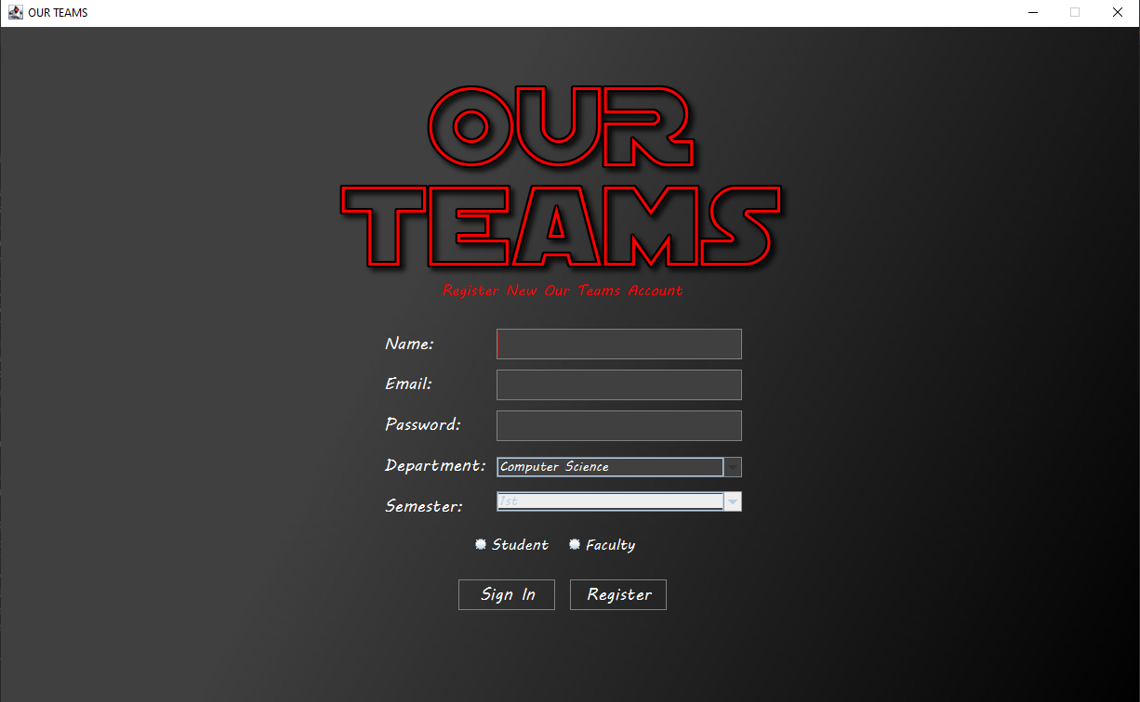

User can sign up for new account, if he enters valid data then his account will be created and be stored in the file from where we will later read to sign into that account.

**After Sing in:**

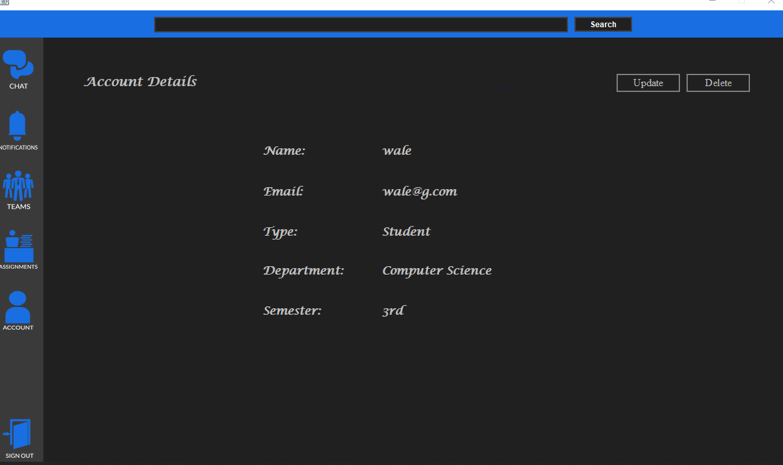

# **Accounts Panel:**



When accounts button is pressed,

Accounts panel becomes visible it shows the data of user’s name, email, type, department etc.

Accounts panel also contains update account and delete account button as well



When **Update button** is pressed

A new dialog box opens up which allows user to edit his existing information.

When **delete button** pressed

An input dialog box opens ask for current users’ password if matches, it deletes account and goes back to sign in panel

# **Teams Panel:**



When this button pressed

Teams panel shows up.

It displays already joined teams if any and shows the create and join button

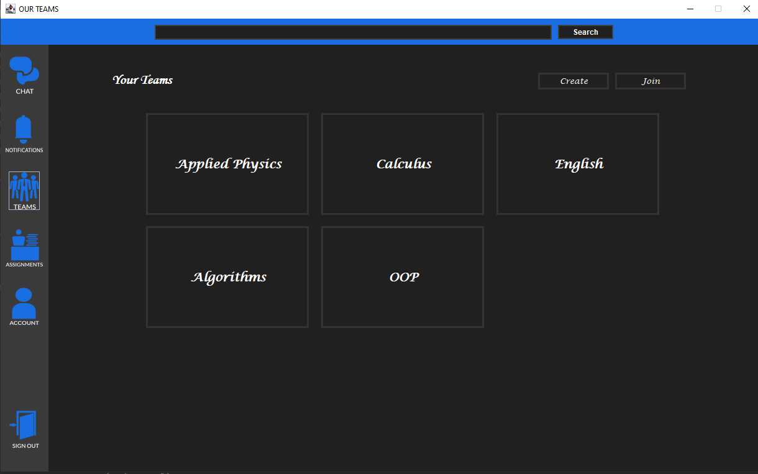

Teams Panel is composed of more Panels including the current teams panel, menu panel, grades, participants and posts panel. User can join, create or leave team by clicking on buttons and they can open a specific team by clicking it. User can post inside a team and see participants of team. Students can also view their grades.

When **create button** is clicked, a dialog box opens which allows user to write name of new team and their join code and team is created instantly

When **join button** is clicked a dialog box open up which ask for join code if join code is matched of some already created team, teams are joined instantly otherwise “invalid join code” message is displayed

# **Notification Panel:**



When this button is pressed it shows notification if any is created or joined or any sort of notifications are displayed

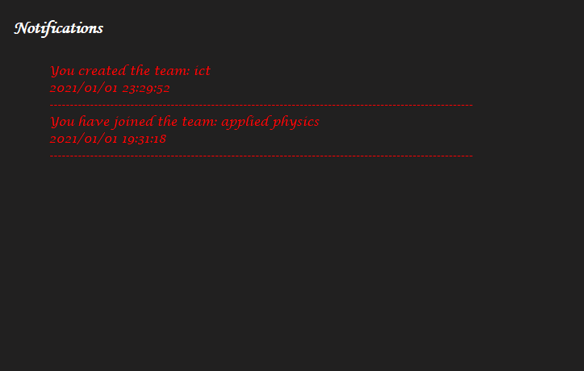

# **Chat Panel:**



When thus button is pressed, chat panel shows up

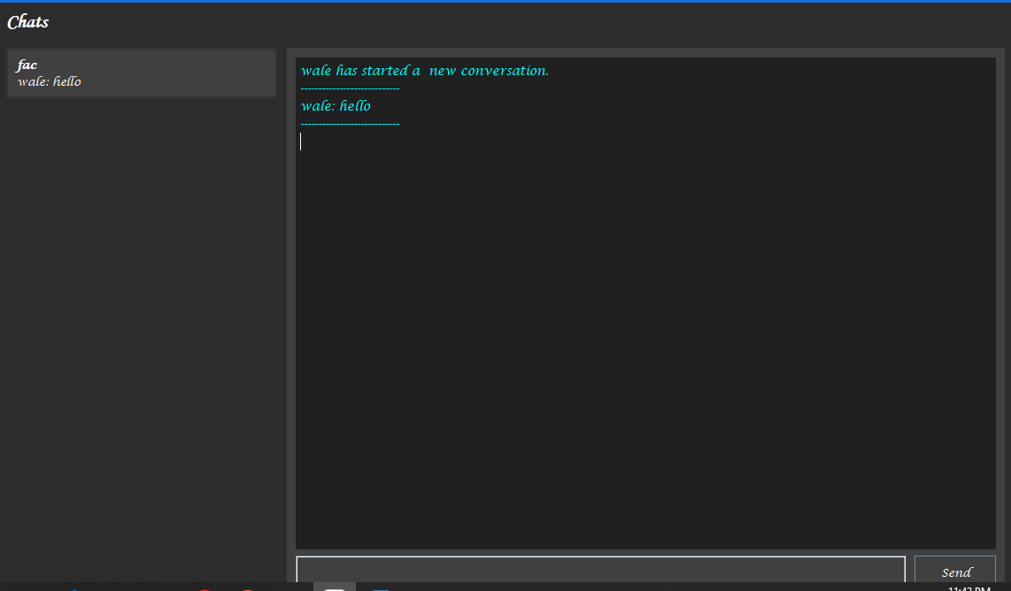

This chat class in GUI contains panel which shows chat list on left side and active chat on right side.

# **Assignment Panel:**



When this button is pressed assignments of joined teams are displayed if any.

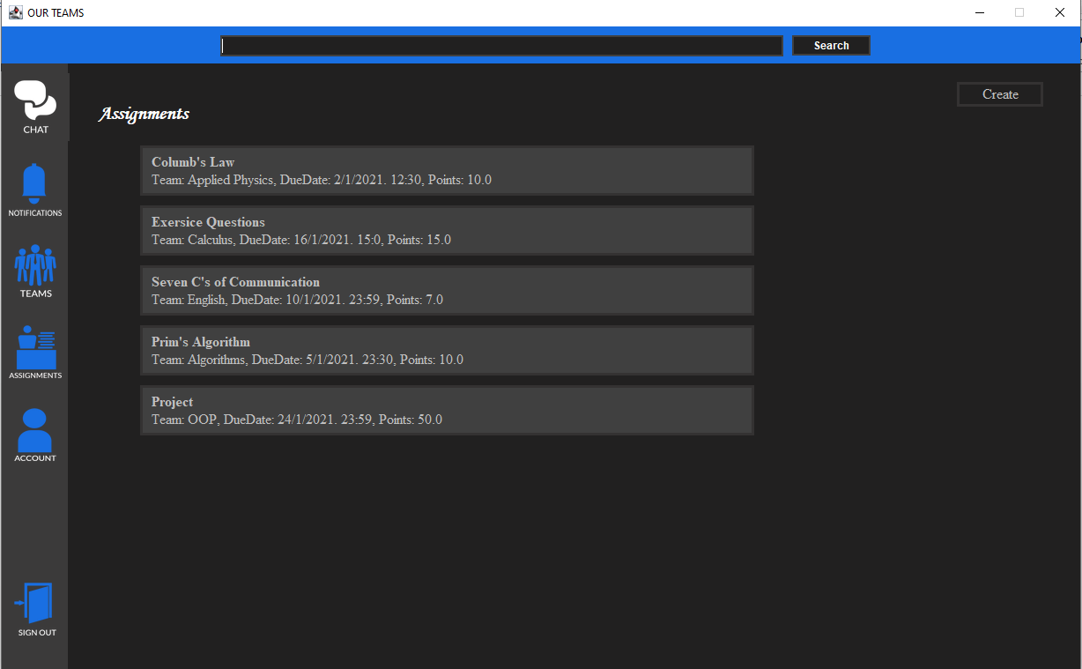

In Assignment’s Panel, there are three major subpanels. The View Assignment Panel shows which assignments are available. On clicking an assignment, Faculty Assignment Panel shows which students have submitted their assignments and the teacher can mark the assignment submitted by student. The Student Assignment Panel shows details of assignment and student can add his assignment file before due time. Faculty member can also create a new assignment, edit assignment or delete an assignment.

## Student Assignment Panel:

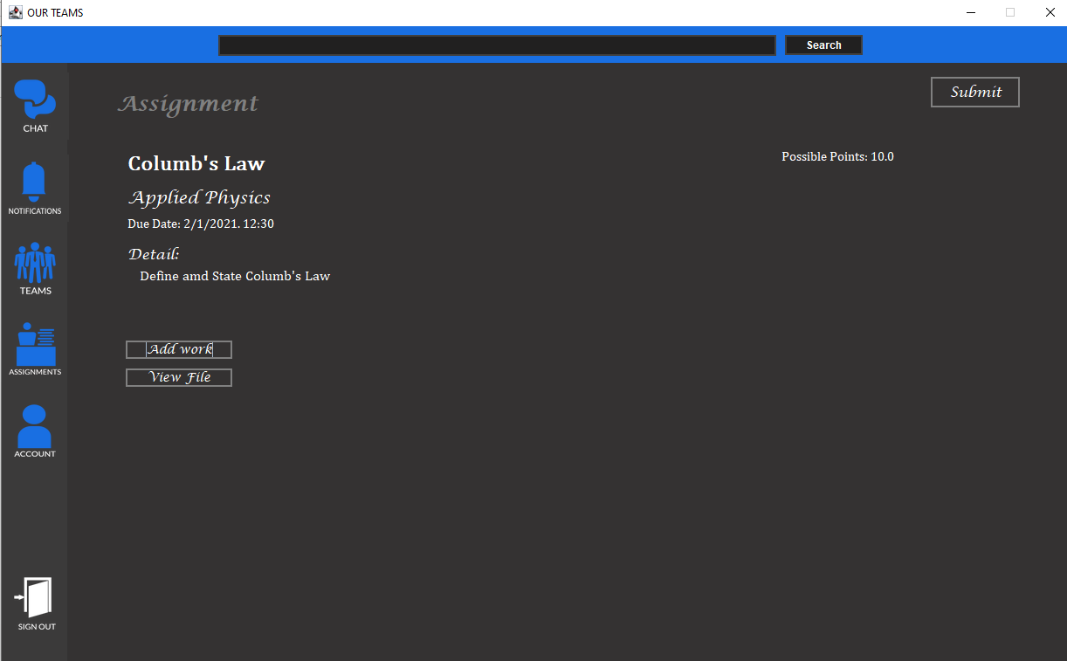

## Faculty Assignment Panel:

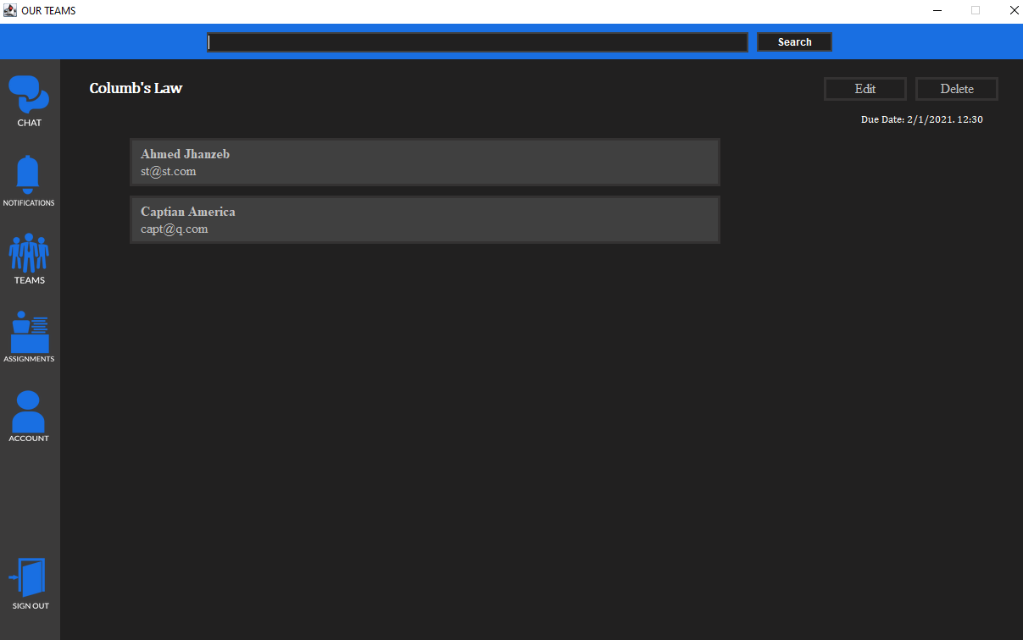

# **Main Backend Classes:**

Class User

Class Student extends User

Class Faculty extends User

Class Assignment

Class Team

# **Class User:**

User is an abstract class having name, email, password, chats, notifications and department as its data members. A user can create, join and leave a team. He can message others, he can delete his account and update his credentials. It also includes static methods for adding / removing / displaying / reading / updating user from a file.

# **Class Faculty extends User:**

Faculty has same data members as user, it has some additional methods of creating returning and updating an assignment.

# **Class Student extends User:**

Class student has an additional data member which is its current semester. It has additional methods of submitting assignment.

# **Class Team:**

A Team has participants, posts, assignments (array list), join code and name. Its methods include add assignment, add participants, add posts, remove participant, and static methods for filing like updateTeamsFile, readTeamsFile, AddTeamtoFile.

# **Class Assignment:**

Assignment has a title, due date, team, detail, total points and assignment data (Array list). Its methods include getters and setters for above data members.